Homework 3
1.
Calculate the V_{UTP} and V_{LTP} in Figure 1. V_{out(max)} =±10 V.

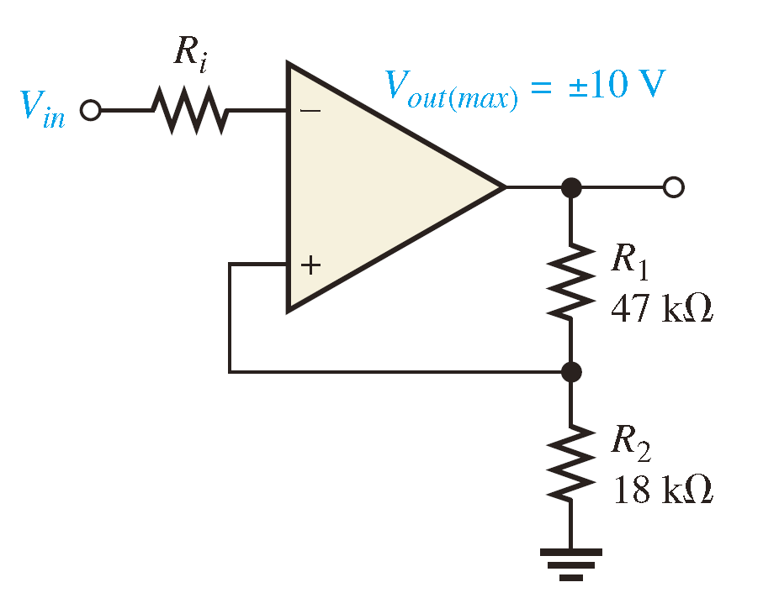
Figure. 1

2.
Draw the output voltage waveform for each circuit in Figure 2 with respect to the input. Show voltage levels. 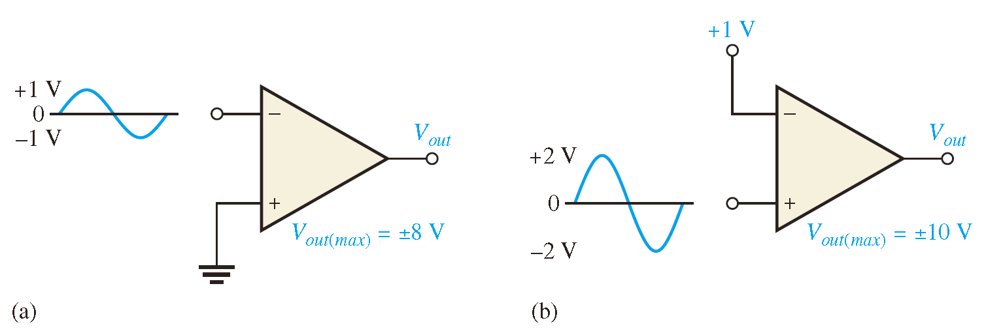
Figure. 2

3.
Determine the output voltage waveform in Figure 3. 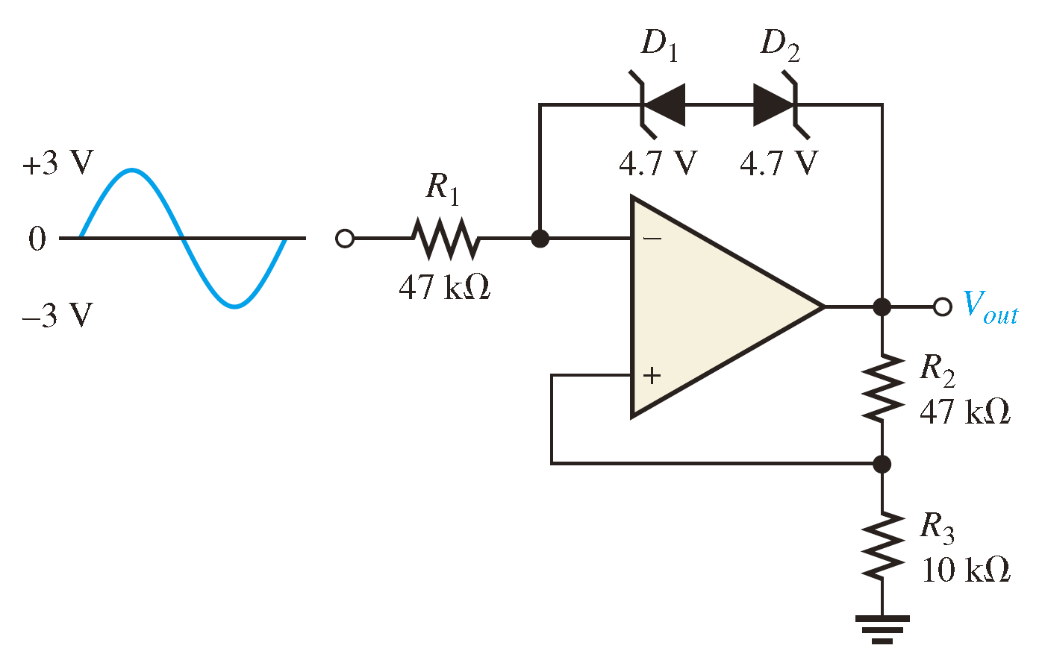
Figure. 3
4.
Refer to Figure 4. Determine the following:
- VR1 and VR2 (b) Current through Rf (c) VOUT
(d) Find the value of Rf necessary to produce an output that is five times the sum of the inputs.
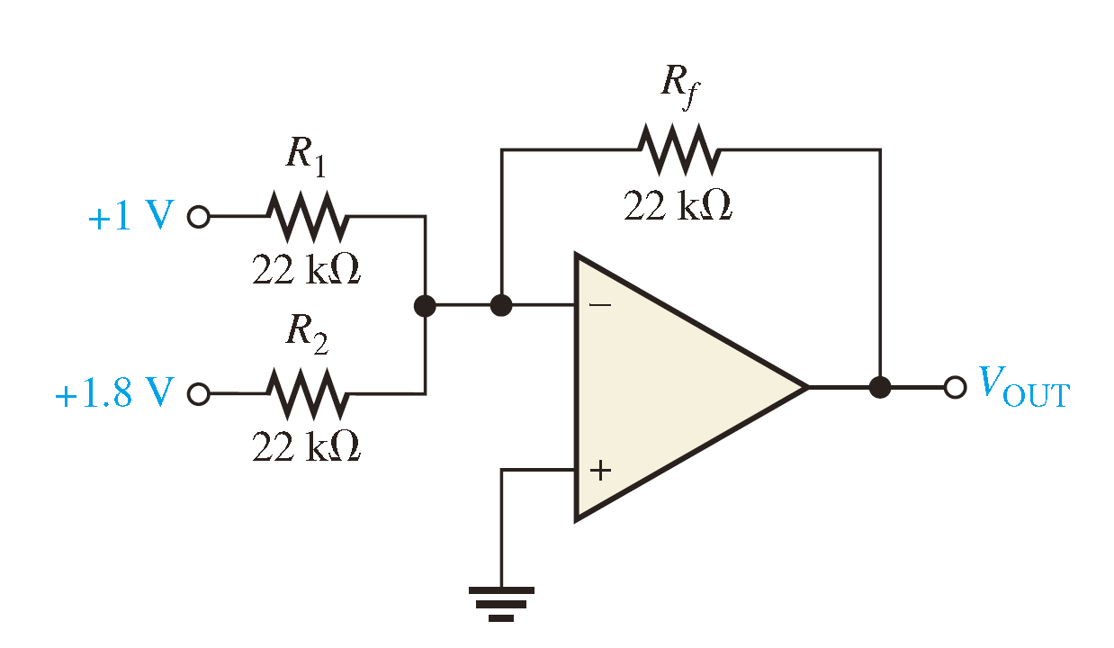
Figure. 4

5.
Find the output voltage when the input voltages shown in Figure 5 are applied to the scaling adder. What is the current through Rf?

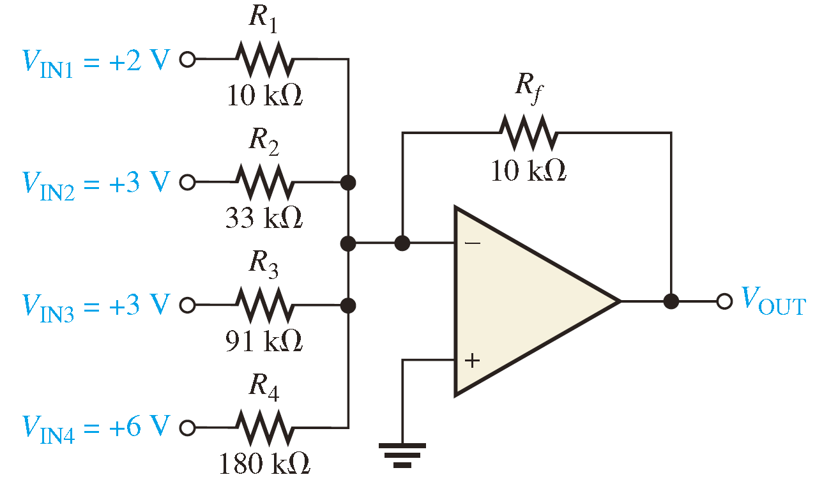

Figure. 5

6.
A triangular waveform is applied to the input of the circuit in Figure 6 as shown. Determine what the output should be and sketch its waveform in relation to the input. What is the magnitude of the capacitor current?

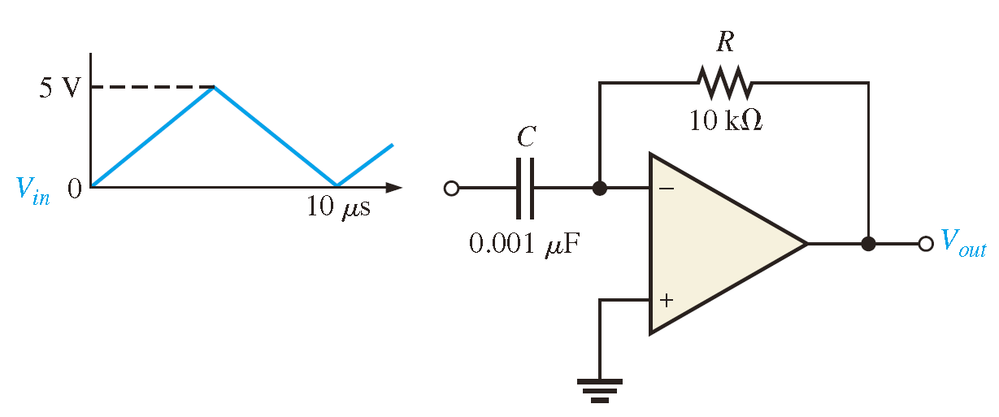
Figure. 6

7.
Beginning in position 1 in Figure 7, the switch is thrown into position 2 and held there for 10 ms, then back to position 1 for 10 ms, and so forth. Sketch the resulting output waveform if its initial value is 0 V. The saturated output levels of the op-amp are ±12 V.
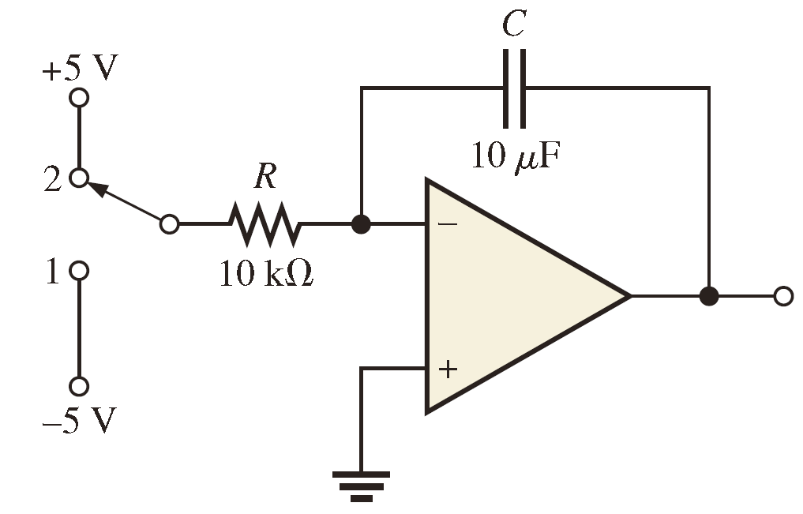
Figure. 7

8.
For the filter in Figure 8, (a) how would you increase the critical frequency? (b) How would you increase the gain?

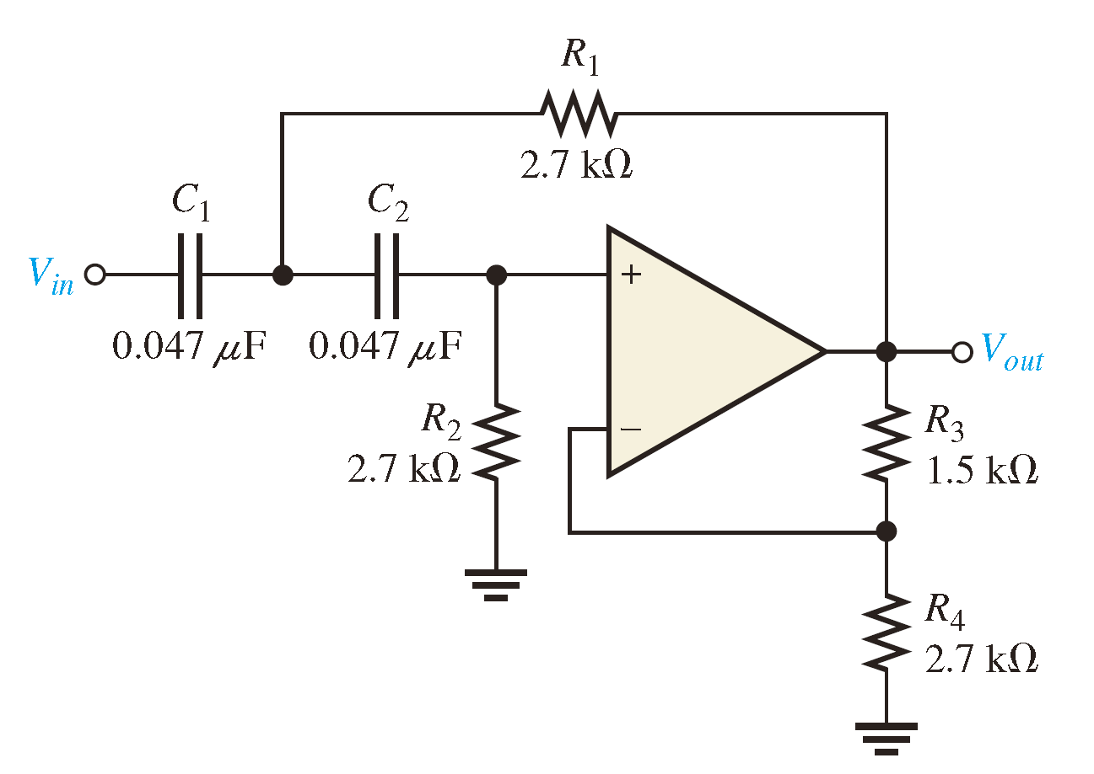
Figure. 8

9.
(1) Determine the center frequency and bandwidth for each filter in Figure 9.

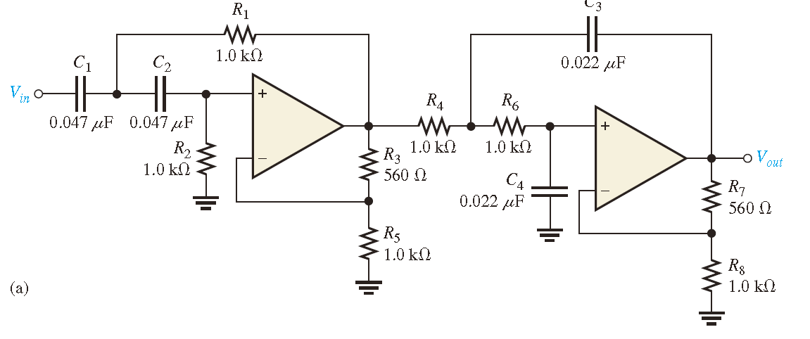
Figure. 9

